# Aim:

To create and conﬁgure a suitable network topology for both LAN and WAN using Cisco Packet Tracer, involving 10-15 computers, switches, and routers. The goal is to simulate the transmission of a message from a computer in one network to a computer in another network, ensuring proper connectivity and communication across diﬀerent network segments.

# Procedure:

## Topology Design: LAN Conﬁguration:

1. Set up a network where at least 10 computers are connected through switches, making sure the LAN segment is well-connected with the switches.

2. Configure a WAN to link this LAN to another network using routers, creating a larger network that allows communication between the different LANs.

## Network Setup in Cisco Packet Tracer: Add Devices:

* 1. Place and connect 10-15 computers within the LAN segment.
  2. Add at least 2 switches to facilitate the connection of the computers.
  3. Introduce at least 2 routers to establish WAN connectivity.

## Conﬁgure IP Addresses:

1. Assign unique IP addresses to each computer within the LAN, making sure all addresses are within the same subnet.

2. Configure the router interfaces with the correct IP addresses to enable routing between the LAN and WAN segments.

3. Set up routing protocols or static routes to ensure smooth communication between the different LANs over the WAN.

**LAN Conﬁguration:**

1. Connect computers to the switches using network cables.
2. Conﬁgure IP addresses on each computer, ensuring that each address is unique and within the same subnet.
3. Connect the switches to each other to ensure network expansion and device communication within the LAN.

## WAN Conﬁguration:

1. Connect the routers to each other to establish the WAN connection.
2. Conﬁgure the router interfaces with IP addresses that facilitate communication across the WAN.
3. Set up routing, either static or dynamic, to ensure that the routers can route traﬃc between diﬀerent LAN segments.

## Simulation: Send a Message:

1. Use Cisco Packet Tracer's simulation mode to monitor network activity, then configure and send a message from a computer in one network (e.g., LAN1) to a computer in another network (e.g., LAN2).

2. Capture the message transmission and verify that it is successfully delivered from one network to the other.

# Result:

## Network Topology and Conﬁguration:

**LAN Setup:**

**Computers:** 12 computers were successfully placed and connected.

**Switches:** 2 switches were used to manage the LAN connections.

**IP Conﬁguration:** IP addresses were assigned to all computers, ensuring they were within the same subnet.

## WAN Setup:

**Routers:** 2 routers were conﬁgured to connect two distinct LANs.

**Router IP Conﬁguration:** Routers were assigned IP addresses on their interfaces to connect the LANs and to each other.

**Routing Protocols:** Static routes were implemented to ensure traﬃc could ﬂow between the LAN segments.

## Message Transmission:

A message was successfully sent from a computer in LAN1 to a computer in LAN2.

The simulation mode in Cisco Packet Tracer conﬁrmed that the message was routed correctly through the WAN and received at the destination computer.

The network topology, IP conﬁguration, routing setup, and message transmission were all veriﬁed to be functioning as expected, demonstrating successful inter-network communication.

## Screenshots:

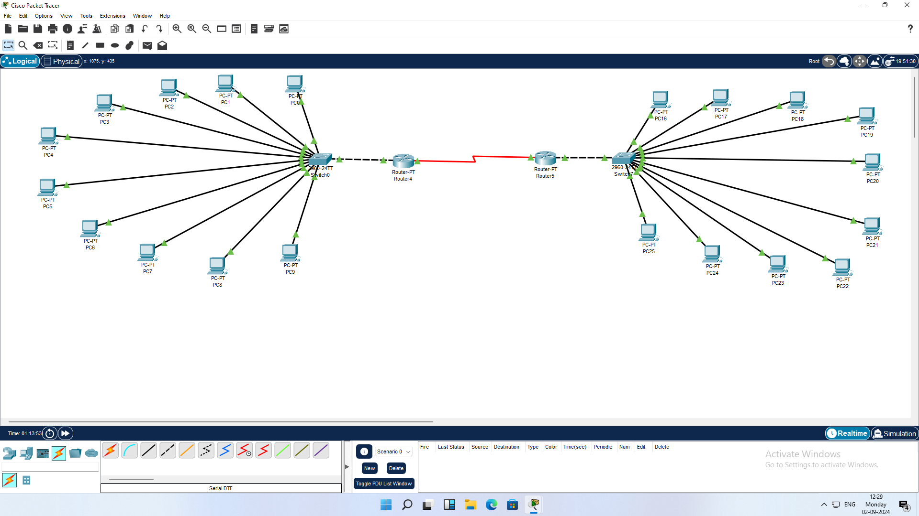

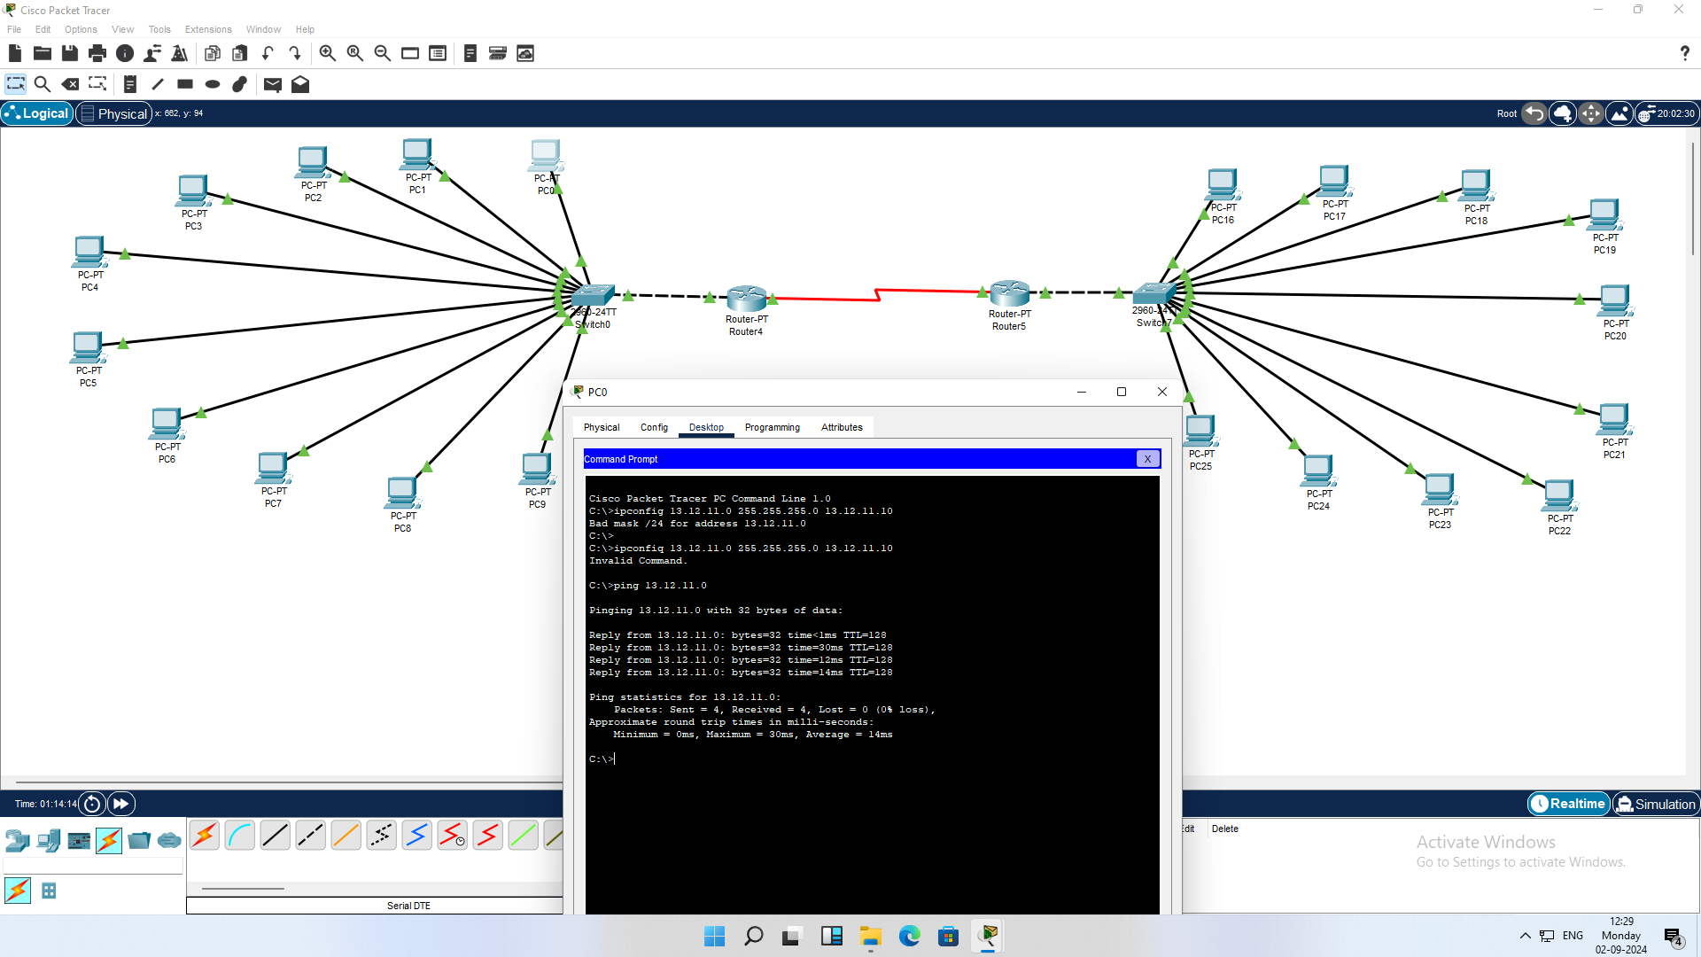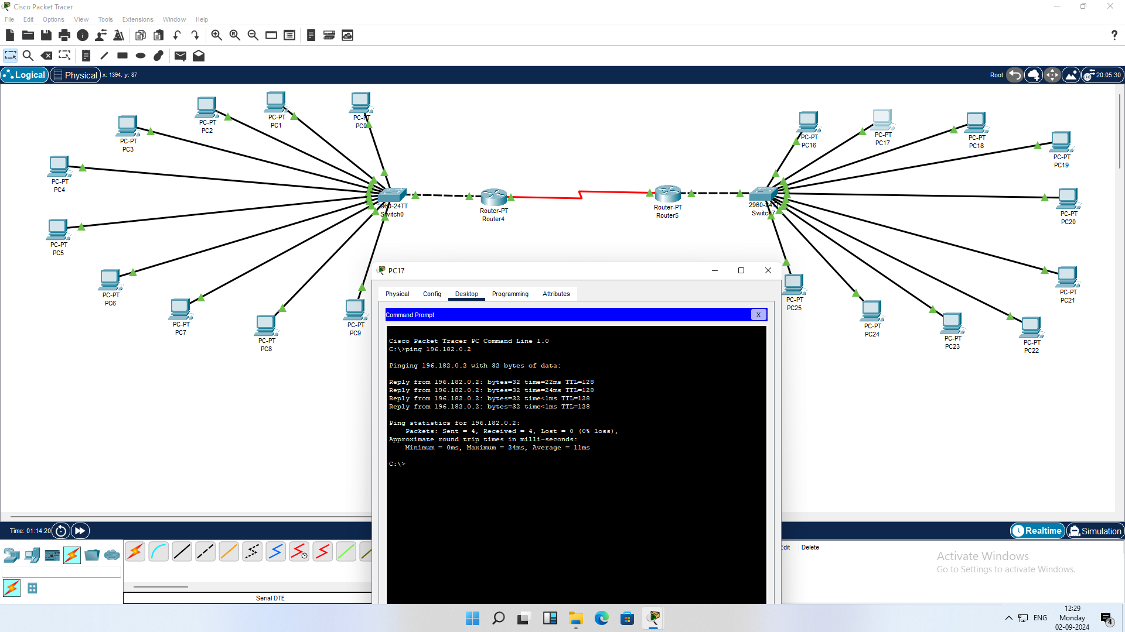

Name: R.Santhosh

Class: CSE-B Reg.No:RA2211003050104